COVID-19

Esperanza Lutheran Church

PREPARED BY:
ReOpening Committee

Section Num. | Table of Contents | Page
1.0 | Engineering Controls
2.0 | Administrative Controls
3.0 | Personal Protective Equipment
4.0 | Conclusion

Appendix | List of Appendices
A | COVID-19 Facility Questionnaire
B | Policies of COVID-19 Administrative Controls

- ENGINEERING CONTROLS (to be completed by 3rd Party assessment)

(Example below)
The HVAC system was found to be in good working condition. The CO₂ levels in which the indoor samples ranged from two hundred fifty-five (255) PPM to one thousand two hundred and fifty (1250) PPM. The outside sample was four hundred and eighty (480) PPM. It is recommended that the site use a MERV 13 filter with at least a monthly change cycle until the end of 2020.This recommendation is for adequate removal of Viruses and Bacterium and does not consider the load of the air handers and differential pressure across the finer filters. Therefore, consideration for the efficiency of the HVAC system regarding air exchange in the buildings may outweigh the potential for upgrading to finer filtration if the performance of the HVAC system.
Table 1. Engineering Controls (Indoor Air Quality Measurements)
Location | CO2 (PPM) | Temperature (°F) | Relative Humidity (%) | Recommendations
Sanctuary | 404 | 83 | 36.2 | N/A
Location 2 | 1250 | 70.2 | 57.4 | N/A
Location 3 | 930 | 69.9 | 50.1 | N/A

- ADMINISTRATIVE CONTROLS
Timeline for ReOpening: The church will reopen in phases. Right now the Office is open 3 days a week from 9-Noon with < 5 people present. The PreSchool is open to students and teachers- their COVID protocol is handled separately.
The church is currently conducting services and fellowship online via YouTube and Zoom (10am on Sundays). This is moving to taping of the YouTube service (music, readings, gospel and sermon) from the Sanctuary as of October 18, 2020. Based on this the capacity for the sanctuary will be 5 persons at a time to maintain social distancing. The Sanctuary will be cleaned and disinfected each Friday afternoon.
The next stage is to conduct outside services with groups < 20 in the open courtyard. The October 25th Confirmation service will be hosted in this manner. This will be used on an exception basis for special services – typical Sunday services will be on line.
The next stage would be to open the sanctuary to groups of < 50 persons after the Percentage of RT PCR Tests that are positive during the last 14 days at <5% and the number of new cases has declined for at least 14 days. The protocol to follow this reopening will be all members enter at the front door and wear facial masks covering their nose and mouth at all times. Temperatures will be taken- anyone over 100.4 degrees will not be admitted. Hand sanitizer will be used upon entry. Family groups will need to be spaced out- at least 6 feet in between family groups. Ushers will ensure groups are keeping their distance. There will not be any singing. All attendees will need to pre-register to ensure we stay 50 people or less – and disclose a good email/phone number to reach them at for use in further contact tracing if needed. Clergy/ministers will be included in the 50 person head count. Holy communion will be dispersed upon exit and taken with the member as the face mask must be taken off to partake in the Communion. There will be no holding hands, no hugging. If a member should get sick within a week of the service, they will call the Office hotline so that any attendees of that service can be notified. A member of the council will contact all attendees including staff to notify them that someone in attendance has become ill. All of those members in contact will not be allowed to attend for 14 days and will be asked to self-quarantine at home. If the member was sick but tested NEGATIVE for COVID they will be asked to stay at home until they are symptom free for seven days. If you feel sick and had a reservation, please stay home. Any employee that has COVID symptoms (fever, cough, aches, shortness of breath) they need to alert the Pastor immediately so that leave protocols can be followed.
The last phase of re-opening will occur when the percentage of RT PCR tests that are positive during the last 14 days are below 3% and the number of new cases has declined for 21 days. At this point the church could enable groups > 50 to gather in the Sanctuary. Masks will be optional but encouraged. Family groups will be encouraged to stay 6 feet apart – we can open the hall to the fellowship room to allow the group to spread out. Hand sanitizer will still be available. Small group singing would be enabled at 12-foot distance, with masks, but no congregational singing.

Office Procedures
In addition to the guidance outlined above, Esperanza has implemented the following workplace procedures to be followed until social distancing guidelines are lifted:
- Deliveries— mail is left in the mailbox by the postal service and the UPS deliveries are left by the door.
- For committees/small group gatherings: They are allowed to meet in < 10 person groups at a social distance of 6 feet. Masks must be worn. Attendance must be taken. A lead will be designated so if contact tracing is needed it can be implemented.

The site has official policies in place to address COVID-19 protocols. However, there is a need for more signage, documented training, and cleaning schedules. Table 2 will detail findings and recommendations.
Table 2. Administrative Controls
Control | Workplace Picture  (Example of sign placement areas) | Recommendation | Example Picture
Social Distancing: The church has established policies for social distancing strategies. OSHA recommends having personnel staying six (6) feet from one another at the workplace. The church is having team members work from home if able. |  | Add specific individual use signage on front doors and in commonly occupied areas that reinforces that personnel should social distance 6’ at all times.  Conduct and document training on this policy. | 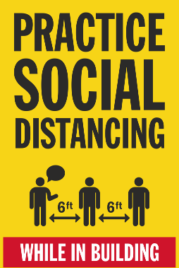
Individual Use:  The church has a common use kitchen with dishes for personnel. There is a possibility that employees/volunteers can be exposed to bloodborne parthenogens or viruses while cleaning equipment for food preparation. |  | Add specific individual use signage in the kitchens/breakrooms that reinforces that personnel should not share dishes, eating utensils, towels, etc.  Conduct and document training on this policy as applicable.
Washing Hands: The church’s restroom is a community use facility. Signs will need to be placed in various areas of the office and common places. There are established policies for washing hands but there needs signage. |  | Add specific hand washing signage in hand washing common areas that details the need to wash for 20 seconds with soap and water.  Conduct and document training on this policy. | 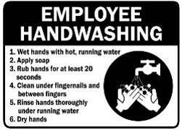
Washing Hands: The church’s restroom is a community use facility. Signs will need to be placed in various high traffic entrance ways of the offices and access points in the building.  Urinal walls or bathroom doors can be utilized. |  | Add signage in common areas to encourage personnel to utilize a paper towel when grabbing door handles, especially when leaving the restroom.  Conduct and document training on this policy. | 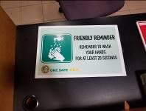
Coughing/Sneezing: COVID-19 is primarily transmitted from person to person and travels via respiratory droplets. The church has established policies online communicating this expectation along with plastic shields as seen in photo. |  | Since this is the primary vessel of spreading the virus, personnel should use the inside of their elbow if tissues are not available. There should be more communication on this policy through signage in common occupied areas.  Conduct and document training on this policy. | 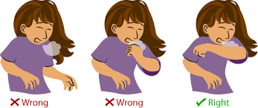
Touching Face:  COVID-19 can be transmitted via absorption and inhalation and personnel should not touch their face as a precaution. The church has established policies communicating this expectation online and clear plastic to avoid direct expulsion possibilities |  | Since this is a vessel of spreading the virus, personnel should not touch their faces with dirty hands. There should be more communication on this policy through signage in common occupied areas.  Conduct and document training on this policy.
Staying Home When Sick: The church has implemented the OSHA recommendation to ensure that personnel who are feeling ill to stay home. The church has established policies communicating this expectation online but there need to be signage in both the residency and common place. |  | Add signage to reinforce policy for personnel to stay home when sick.  Conduct and document training on this policy.
Cleaning and Disinfecting Surfaces: The church has janitorial services on aweekly schedule. It is recommended that the church should ensure common workspaces are cleaned daily and provide dispensary locations in and around entrances. |  | The church should construct a cleaning schedule form to have employees who clean surfaces log the date, time, and area cleaned.  Also, have cleaning vendor scheduled to clean surfaces at least weekly can be an effective control.
Floor Surfaces:  Viruses are commonly carried into new environments on people’s shoes. Cleaning the floors and baseboards is important to mitigate spread opportunities.  The church has janitorial services on a daily and weekly schedule. |  | Have the cleaning vendor scheduled to clean floors bi-weekly for the rest of 2020.  Have the cleaning vendor disclose the names of all cleaning products utilized with SDS forms.  There is current plans for a cleaning vendor to be utilized in the facility. | 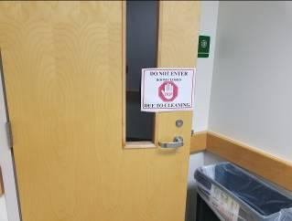
Signage: The church should have more signage on entrances and in conspicuous locations that educate personnel on exposure prevention and reaffirming church policies to combat the COVID-19 from spreading in the facility. |  | This is an example of the type of signage, but it should address the main points of how to prevent transmission of COVID-19.  These should be placed on front doors and in noticeable areas in the facility for employees and guests. | 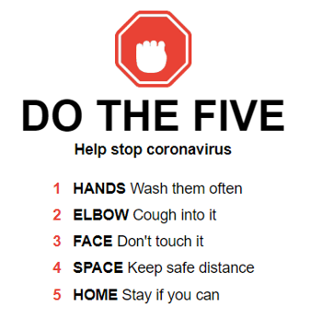
Internal Communications: The church currently has weekly meetings to address updates with the COVID-19 Pandemic.  A weekly meeting is currently being conducted twice a week via zoom with response criteria for the faculty, students, and staff. |  | In addition, communicate gratitude to personnel for their contribution to combat the spread of the virus.  All communications should be discussed with every leadership team member so that messaging is in alignment.

- PERSONAL PROTECTIVE EQUIPMENT

The site does interface with the community and does perform activities that would bring personnel in direct contact with COVID-19. Therefore, it is considered a “high risk” work environment and PPE is recommended to combat COVID-19. The church currently requires personnel to wear a face mask which is in alignment with State and Federal guidelines. The church will buy disposable masks to give out to those that have forgotten to bring one for a gathering.

- CONCLUSION

The church strives to navigate this pandemic in a way that prioritizes employee and member safety. We will look to the experts and current data to trigger moving the current “closed” status more in the open direction. In the meanwhile digital services will continue so that any member regardless of risk tolerance can participate. We look forward to the day we can worship in person for an even richer experience.

Appendix A

(COVID-19 Facility Questionnaire)

Example – done with HVAC assessment

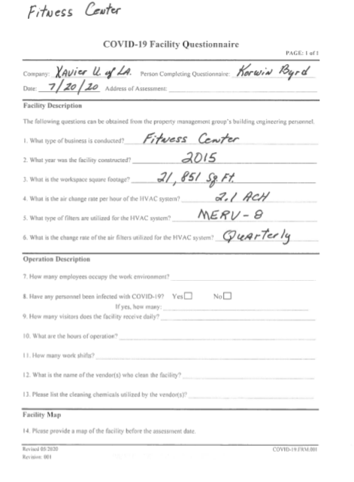

Appendix C

Approved EPA lists for chemicals

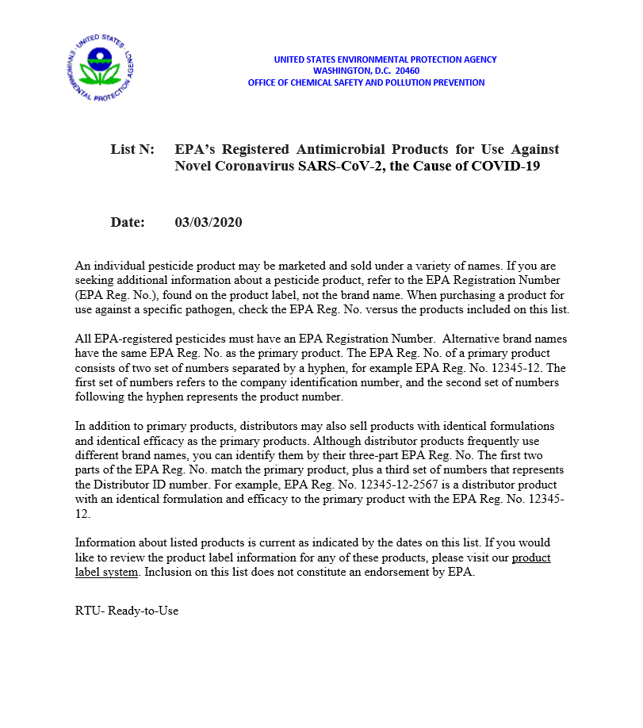

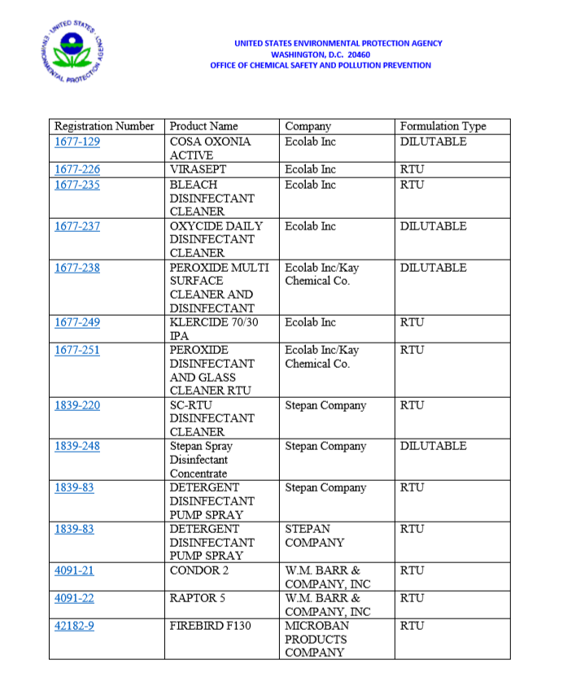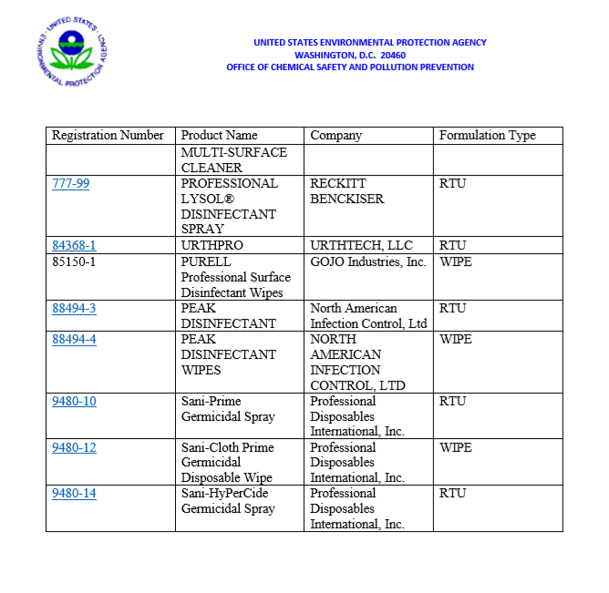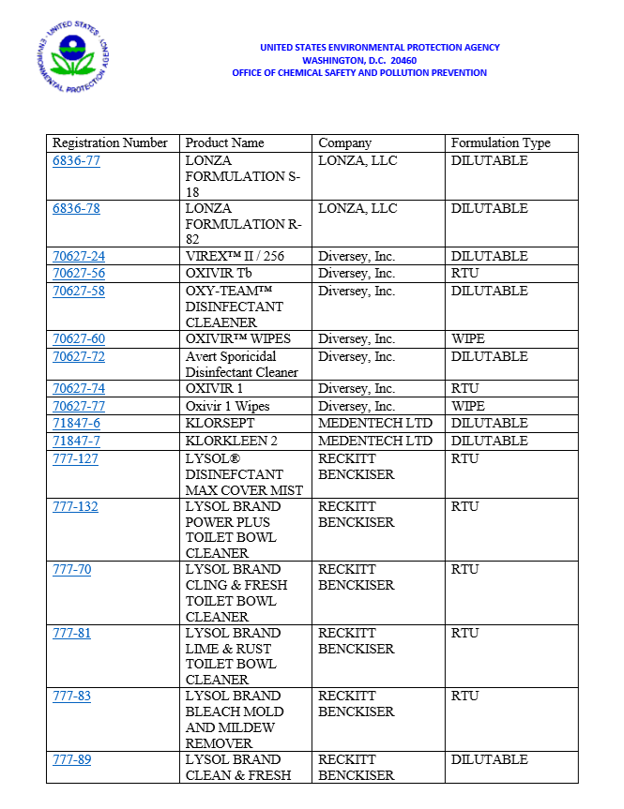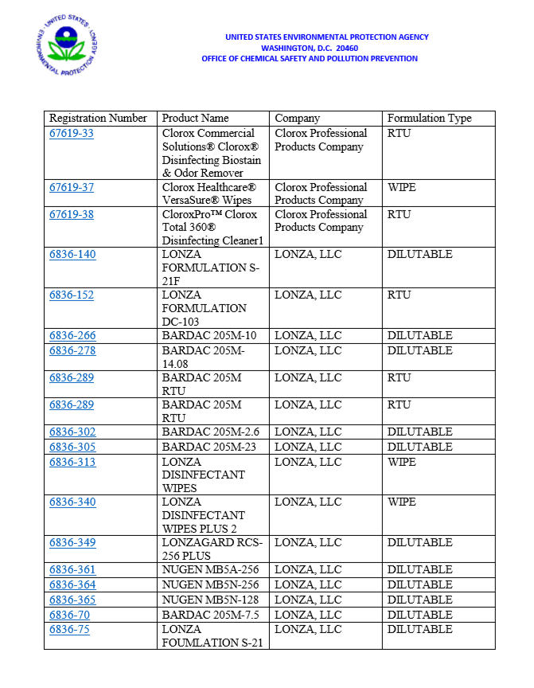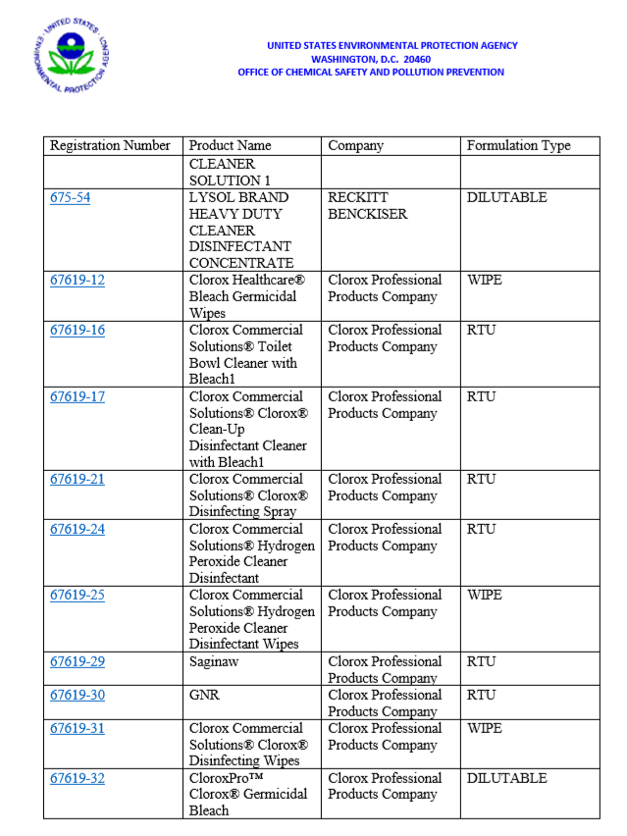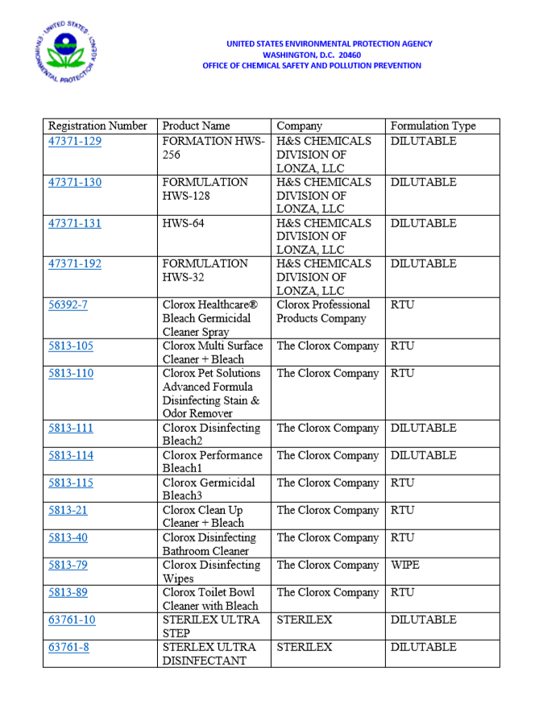

Cleaning and Disinfection Training

