a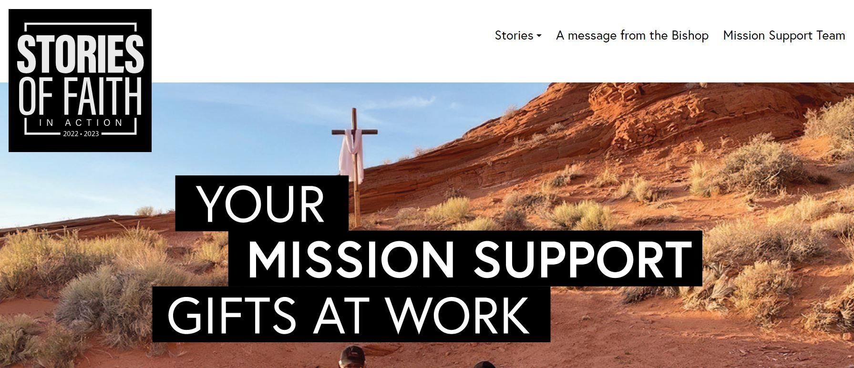

NOVEMBER 2023 Mission Support Memo
STORYTELLING ENGAGEMENT

Goodness of God
As you read this story, what connects with you?
How does your congregation share resources with your synod?
A story from our Southeastern Synod on the goodness of Mission Support
Each month we have been sharing stories of how Mission Support empowers us to be church together, allowing the goodness of God to flow beyond ourselves, our own congregations, and out into our communities and around the world.
Ever wonder how Mission Support makes a difference? Well, as Lutherans we believe that Christ has freed us from sin and death, and even from ourselves, so that we can love and serve our neighbors. One way we turn our faith into action is by making a financial gift — an offering — to our congregation. Then each year ELCA congregations share an intent to send a portion of their offerings to fund ELCA ministries in their synods and beyond. Some call this benevolence, some call it synod share and we call these funds Mission Support — support so we can equip mission across our church.
The Rev. Jonathan Hemphill, assistant to the bishop for congregational life with the Southeastern Synod, shared an inspiring story on why Mission Support is grounded in Psalm 34:8: “Taste and see that the Lord is good!” Throughout 2024 the Southeastern Synod stewardship team will focus on this Scripture. As his invitation for all congregations to generously provide intents, Hemphill shared these words in a video: “ We have tasted the goodness of God in our community, in our congregations, in various ways. We have tasted the goodness of God in our families, in our relationships. Even amid the world we live in today with all of the challenges, we still have an opportunity to share the goodness and generosity that God gives us to others.” He reminds us that “Mission Support is how we’re able to bring goodness to others and how we together bring hope, love and justice to others.”

This message prompts us to see hope and goodness in the everyday goodness of God that we all experience. It reminds us that we are called to share that goodness beyond ourselves through our generosity to our congregations, which in turn are generous to our synods, who are generous to our greater church, so the church can be generous in places we cannot even imagine. To find out even more about Mission Support and connect with more stories, check out the Stories of Faith in Action page at livinglutheran.org/sofia/.

ENGAGE WITH US

What great opportunities we have to share with you all now that the Congregation and Synod Support Team includes stewardship.

Please check out the Congregational Stewardship Vimeo Page! If you ever miss a presentation or webinar (though we encourage you to show up for these in person if you can), find them on our ELCA Congregational Stewardship Vimeo page. It’s perfect for stewardship teams that want to do some continuing education or congregation councils curious about what’s happening in the realm of stewardship.

Have a great stewardship resource to share? Please send tips on articles, books, movies and other media to tim.brown@elca.org. The best gifts are those that are shared!

GRATEFUL

As we enter into this time of Advent, a time of watchfulness, preparation and waiting for the light of Christ to come, we as your Congregation and Synod Support Team continue to be grateful for the ways we stay connected. We are connected with our bishops, directors for evangelical mission, stewardship leaders, storytellers and communicators, congregational leaders and each person who engages in the work of Mission Support and stewardship by sharing our stories of mission and ministry. These stories allow us to celebrate the anticipation and wonder of Christ’s light more fully. As Hemphill said so beautifully, we bring “goodness to others and … together bring hope, love and justice to the world around us.” We continue to be deeply grateful for your generosity through Mission Support and hope you feel the wonder of all it allows us to do — together.

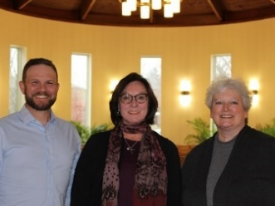
In deep gratitude,

Victoria Flood, Senior Director for Congregation and Synod Support
Nick Kiger, Director for Mission Support
Karen Kretschmann, Coordinator for Storytelling Engagement

